Supplementary Information
Supplementary Methods S1. City-node classification for the country layer
We extracted urban nodes from the Natural Earth populated-places layer. National capitals were identified from Admin-0 capital and Admin-0 capital alt; provincial or regional capitals from Admin-1 capital and Admin-1 region capital; and major cities by POP_MAX >= 100,000. Each country was required to have at least one national-capital node.
Because different parts of the analysis use different cached layers, country counts are reported according to the actual input used. The road and health inventories contain 50 country folders, whereas the cached country-layer OD summary contains 49 countries because WestSahara does not have a valid OD summary in that output.
Table S1. Country-count convention used in the analysis
Quantity | Count | How it should be described
Road-speed country folders | 50 | 50 country folders
Health-access cached outputs | 50 | 50 countries/folders
Africa-layer capital file | 49 capitals | 49 country folders
Africa-layer city-node file | 83 nodes | 83 city nodes across 49 country folders
Country-layer city-node file | 801 nodes | 801 settlement nodes across 50 country folders
Country OD summary | 49 countries | 49 countries, excluding WestSahara

Supplementary Methods S2. HDM-4 IRI model and parameter choices
We used the HDM-4 gravel-road roughness formulation to estimate unpaved-road operating speeds. The default parameter values were chosen to represent low-volume gravel roads under limited maintenance. Sensitivity checks showed that the main accessibility results were insensitive to reasonable perturbations in initial roughness, roughness cap and traffic composition.
Table S2. HDM-4 parameters and sensitivity checks
Parameter | Baseline | Sensitivity range | Result
Initial roughness, IRI0 | 6.0 | 4.0 / 8.0 | Change in coverage loss < 1 percentage point
Maximum roughness cap, IRImax | 12.0 | 10.0 / 14.0 | Change in coverage loss < 0.01 percentage points
Mean gravel depth, MGD | 0.5 m | fixed in main analysis | Defined as gravel depth, not grading interval
ADT | 50 vehicles/day | 20 / 100 | Change in coverage loss < 0.1 percentage points
Light vehicles, ADL | 42 | 10 / 80 | Change in coverage loss < 0.1 percentage points
Heavy vehicles, ADH | 8 | 2 / 30 | Change in coverage loss < 0.1 percentage points
Supplementary Methods S3. Speed-roughness mapping
Road roughness was converted to operating speed using the following lookup relation. Intermediate values were interpolated linearly.
Table S3. IRI-to-speed conversion
IRI | 6 | 8 | 10 | 12 | 14 | 16 | 18 | 20
Speed（km/h） | 106 | 80 | 64 | 53 | 46 | 40 | 35 | 32

The lookup table follows observed vehicle speeds on unpaved roads in sub-Saharan Africa reported in the HDM-4 calibration literature (Bennett and Paterson 2000, Vol. 5). Greater roughness lowers speed because drivers slow down to maintain vehicle control and limit damage. The lower anchor (IRI = 6 m km-1, speed = 106 km h-1) represents a newly graded gravel road. The upper anchor (IRI = 20 m km-1, speed = 32 km h-1) represents a severely degraded surface near the limit of normal vehicle passability. IRI values outside [6, 20] were clipped to the nearest endpoint before interpolation.
Free-flow speed is appropriate here because rural unpaved roads in Africa generally operate below capacity. On these segments, surface condition, rather than congestion, dominates travel time.
Supplementary Methods S4. Robustness of extreme-climate scenario construction
The main analysis defines the adverse-climate state using high precipitation and high soil-moisture conditions. To test whether the headline results depend on this construction, we varied the precipitation percentile, the soil-moisture threshold and the passability penalty function.
Precipitation percentiles were varied across P90, P95, P97.5 and P99. Soil-moisture thresholds were varied across P70, P75 and P80. We compared proportional penalties, binary threshold blockage and smooth bounded penalties, including capped-linear and logistic forms.
For each scenario, we evaluated the continent-scale amplification factor, the health-access headline metrics and the targeted-paving recovery rate. The continent-scale amplification factor was recomputed using the cached Africa graph checkpoint. The health-access and recovery outcomes were evaluated using cached headline outputs and scenario-severity scaling, so these should be interpreted as a screening robustness check rather than a full rerun of every downstream pipeline.
Table S4. Continuous extreme-climate construction sensitivity
Precip. | Soil | Amplification | 1h loss (%) | Mean TGR | Recovery 0.1% (%) | Recovery 1% (%) | Top-25 Jaccard
P90 | P70 | 1.192 | 4.23 | 17.87 | 71.73 | 91.16 | 1.000
P90 | P75 | 1.200 | 3.86 | 17.85 | 71.73 | 91.16 | 1.000
P90 | P80 | 1.207 | 3.56 | 17.85 | 71.73 | 91.16 | 0.852
P95 | P70 | 1.190 | 4.30 | 17.98 | 71.73 | 91.16 | 1.000
P95 | P75 | 1.198 | 3.93 | 17.96 | 71.73 | 91.16 | 1.000
P95 | P80 | 1.205 | 3.63 | 17.97 | 71.73 | 91.16 | 0.852
P97.5 | P70 | 1.189 | 4.34 | 18.03 | 71.73 | 91.16 | 1.000
P97.5 | P75 | 1.197 | 3.96 | 18.02 | 71.73 | 91.16 | 1.000
P97.5 | P80 | 1.205 | 3.66 | 18.03 | 71.73 | 91.16 | 0.852
P99 | P70 | 1.189 | 4.36 | 18.06 | 71.73 | 91.16 | 1.000
P99 | P75 | 1.197 | 3.99 | 18.05 | 71.73 | 91.16 | 1.000
P99 | P80 | 1.204 | 3.68 | 18.07 | 71.73 | 91.16 | 0.852

Table S5. Passability-function stress-test bounds across the percentile grid
Penalty form | Amplification | 1h loss | Mean TGR | Top-25 Jaccard | Interpretation
proportional/capped-linear | 1.189-1.207 | 3.56-4.36% | 17.85-18.07 | 0.852-1.000 | Central continuous specification
logistic | 1.079-1.149 | 6.67-12.05% | 26.03-26.78 | 0.667-0.786 | Smooth stress test; magnitude is calibration-sensitive
binary threshold blockage | 0.870-0.876 | 38.99-42.08% | 37.69-50.52 | 0.220-0.220 | Conservative stress-test bound, not a central estimate

The headline results are stable under alternative precipitation percentiles and soil-moisture thresholds when continuous passability penalties are used. Binary blockage and steep logistic penalties produce substantially larger access losses and are therefore reported as conservative stress-test bounds rather than pooled with the central estimates.
Supplementary Methods S5. Paved-road climate-neutral assumption
The Africa-layer analysis treats paved roads as climate-neutral links in the default specification. Because this is a strong assumption, we tested alternative paved-road specifications. First, paved links were assigned a higher fixed speed of 80 km/h instead of the median unpaved-road speed. Second, paved links were allowed to experience mild or moderate climate degradation.
We compared each specification using cross-country travel-time increase, the amplification factor, rank correlation in corridor increases and overlap in the top corridor hotspots.
Table S6. Robustness of Africa-layer results to paved-road assumptions
Paved-road assumption | Cross-country increase (%) | Amplification | Spearman | Top-10 Jaccard | Top-25 Jaccard | Top-50 Jaccard | Interpretation
Default web1 assumption | 36.55 | 1.198 | 1.000 | 1.000 | 1.000 | 1.000 | Baseline
Fixed 80 km/h, climate-neutral | 36.57 | 1.199 | 1.000 | 1.000 | 1.000 | 0.961 | Stable
Fixed 80 to 72 km/h, light degradation | 41.80 | 1.132 | 0.985 | 0.818 | 0.852 | 0.852 | Broadly stable
Fixed 80 to 65 km/h, moderate degradation | 47.13 | 1.075 | 0.924 | 0.818 | 0.667 | 0.695 | Sensitivity boundary
The Africa-layer result is robust to assigning paved links a higher fixed speed and to allowing mild paved-road degradation. Under moderate paved-road degradation, the magnitude of travel-time increase rises and the corridor hotspot ranking changes more substantially. We therefore report the moderate-degradation case as a sensitivity boundary rather than as an alternative central estimate.
Supplementary Methods S6. Health facilities, population assignment and 50-km exclusion
We used health facilities as destinations because access to emergency and primary care is highly time-sensitive. Delays in reaching care can increase preventable mortality, especially for obstetric emergencies, trauma and infectious disease crises. Unlike schools, markets or government offices, healthcare access also has an established clinical benchmark: the WHO 1-hour threshold. This makes it suitable for consistent cross-country comparison.
For each road-network node, we computed travel time to the nearest facility using a multi-source Dijkstra search seeded with all facility anchor nodes. This rule allows facilities to substitute for one another. If two facilities can serve a population node, the closer one determines travel time. Assigning each origin to a fixed facility would overstate travel times in areas with overlapping facility catchments.
We evaluated an 18-scenario health-access robustness grid varying facility definition, snap threshold and population mapping. The facility sets were hospital only, hospital + clinic + health centre and plus pharmacy; snap thresholds were 25, 50 and 100 km; and population assignment used nearest-node or nearest-segment proxy mapping.
Table S7. Health-access robustness grid
Facility set | Snap km | Population mapping | Countries | 1h loss (%) | Mean TGR | TGR > 1 | rho loss | rho TGR
hospital+clinic+health centre | 25 | nearest node | 48 | 4.91 | 16.49 | 35 | 0.921 | 0.832
hospital+clinic+health centre | 25 | nearest segment proxy | 48 | 4.86 | 16.01 | 36 | 0.928 | 0.854
hospital+clinic+health centre | 50 | nearest node | 50 | 4.26 | 12.21 | 27 | 0.977 | 0.967
hospital+clinic+health centre | 50 | nearest segment proxy | 50 | 4.25 | 12.83 | 28 | 0.985 | 0.936
hospital+clinic+health centre | 100 | nearest node | 50 | 3.98 | 14.98 | 24 | 0.976 | 0.925
hospital+clinic+health centre | 100 | nearest segment proxy | 50 | 4.00 | 13.23 | 24 | 0.969 | 0.898
hospital only | 25 | nearest node | 46 | 6.31 | 10.38 | 38 | 0.805 | 0.634
hospital only | 25 | nearest segment proxy | 46 | 6.18 | 13.25 | 40 | 0.814 | 0.620
hospital only | 50 | nearest node | 49 | 5.72 | 11.01 | 35 | 0.895 | 0.817
hospital only | 50 | nearest segment proxy | 49 | 5.68 | 10.70 | 36 | 0.895 | 0.779
hospital only | 100 | nearest node | 49 | 5.12 | 12.75 | 26 | 0.938 | 0.803
hospital only | 100 | nearest segment proxy | 49 | 5.11 | 13.02 | 26 | 0.931 | 0.705
plus pharmacy | 25 | nearest node | 48 | 4.74 | 18.24 | 33 | 0.947 | 0.835
plus pharmacy | 25 | nearest segment proxy | 48 | 4.71 | 16.84 | 34 | 0.938 | 0.853
plus pharmacy | 50 | nearest node | 50 | 4.17 | 16.24 | 27 | 0.996 | 0.979
plus pharmacy | 50 | nearest segment proxy | 50 | 4.17 | 13.42 | 27 | 0.993 | 0.948
plus pharmacy | 100 | nearest node | 50 | 3.94 | 18.63 | 21 | 0.976 | 0.920
plus pharmacy | 100 | nearest segment proxy | 50 | 3.96 | 16.06 | 23 | 0.967 | 0.901

Table S8. Fig. 3c regression stability and 50-km exclusion audit
Check | Scope | Result
Health-access grid | 18 variants | 1h coverage-loss proxy 3.94-6.31%; mean TGR 10.38-18.63; coverage-loss rank rho 0.805-0.996
Fig. 3c facility-density coefficient | 18/18 same-signed | Coefficient -0.0378 to -0.0295; p < 0.001 in all variants; R2 0.309-0.466
50-km facility exclusion | hospital+clinic+health centre, nearest-node | Median 53.1%; mean 51.7%; range 0.0-99.0%
50-km population exclusion | hospital+clinic+health centre, nearest-node | Median 54.6%; mean 49.4%; max 97.8%

Table S9. Country-level 50-km exclusion audit
Country | Facility excluded (%) | Population excluded (%) | Facilities | Sampled pixels
SouthSudan | 96.1 | 97.8 | 463 | 100000
Nigeria | 84.5 | 95.5 | 4999 | 100000
Mauritania | 94.7 | 94.6 | 114 | 100000
Sudan | 99.0 | 94.4 | 517 | 100000
Gabon | 96.7 | 93.5 | 215 | 95747
Mozambique | 90.3 | 91.1 | 976 | 100000
Algeria | 91.1 | 91.0 | 2901 | 100000
SouthAfrica | 88.7 | 90.6 | 1694 | 100000
Namibia | 88.6 | 89.7 | 341 | 100000
IvoryCoast | 86.0 | 85.8 | 709 | 100000
Tanzania | 82.8 | 85.1 | 4338 | 100000
Botswana | 76.6 | 82.1 | 188 | 100000
Zimbabwe | 79.3 | 77.9 | 978 | 100000
CentralAfrican | 89.5 | 77.5 | 285 | 100000
Guinea | 78.9 | 70.6 | 380 | 100000
Madagascar | 54.2 | 68.2 | 413 | 100000
Tunisia | 71.0 | 65.6 | 383 | 100000
Cameroon | 74.8 | 64.9 | 1180 | 100000
Equatorial | 93.3 | 63.3 | 15 | 36183
Ghana | 50.8 | 62.5 | 950 | 100000
Ethiopia | 51.1 | 61.8 | 785 | 100000
Angola | 65.1 | 61.5 | 427 | 100000
Eritrea | 34.6 | 61.2 | 26 | 100000
Gambia | 40.0 | 59.8 | 105 | 78620
CongoDR | 83.2 | 56.2 | 1616 | 100000
Liberia | 59.0 | 53.0 | 952 | 100000
Congo | 35.9 | 50.5 | 131 | 100000
Morocco | 44.2 | 45.6 | 724 | 100000
SierraLeone | 42.4 | 45.3 | 370 | 100000
Malawi | 57.1 | 44.6 | 273 | 100000
Chad | 52.1 | 42.4 | 292 | 100000
Libya | 39.4 | 40.2 | 1609 | 100000
Uganda | 28.2 | 31.7 | 6180 | 100000
Togo | 18.6 | 28.6 | 582 | 100000
Zambia | 31.5 | 27.8 | 1541 | 100000
Niger | 29.4 | 26.3 | 367 | 100000
BurkinaFaso | 8.9 | 19.3 | 878 | 100000
Kenya | 9.9 | 14.6 | 1838 | 100000
Djibouti | 0.0 | 13.5 | 31 | 18980
Lesotho | 12.4 | 12.3 | 153 | 100000
GuineaBissau | 63.4 | 12.1 | 41 | 88824
Mali | 7.5 | 10.2 | 810 | 100000
Benin | 1.0 | 2.9 | 485 | 100000
Egypt | 10.9 | 2.3 | 943 | 100000
Senegal | 3.1 | 2.2 | 512 | 100000
Rwanda | 2.2 | 1.6 | 875 | 100000
Somalia | 1.0 | 0.7 | 97 | 100000
Burundi | 0.1 | 0.3 | 894 | 100000
Swaziland | 0.0 | 0.0 | 41 | 100000
WestSahara | 87.5 | 0.0 | 16 | 0

The 1h coverage-loss proxy remains within 3.94-6.31%, and country-level coverage-loss rankings remain highly correlated with the baseline. Regression coefficients for the Fig. 3c facility-density specification remain negative and statistically significant across all facility-set, threshold and population-mapping variants. However, the 50-km rule is spatially uneven. Under the hospital + clinic + health-centre definition, the median facility exclusion is 53.1% and the median population exclusion is 54.6%. We therefore report the full country-level exclusion table as a limitation and robustness audit.
Supplementary Methods S7. Bottleneck score and recovery-index robustness
The main intervention result reports that paving only 0.1% of prioritized unpaved roads recovers about 71.7% of the estimated climate-induced accessibility loss, while paving 1% recovers about 91.2%. We tested whether this result depends on the exact construction of network importance, climate vulnerability and bottleneck score.
The sensitivity checks vary the NI gravity exponent across 1.5, 2.0 and 2.5; compare raw NI x CV, standardized product and additive/rank-sum scoring; vary the high-NI/high-CV threshold from median split to upper quartile and top decile; and evaluate top-K stability for K = 500 and the top 1%, 3%, 5% and 10% of unpaved links. Recovery is reported as a fraction of scenario loss, so the reduced-form recovery-index scaling check leaves the 0.1% and 1% recovery fractions unchanged in the cached paving experiment.
Table S10. Recovery robustness
Paving budget | Edges paved | Guided recovery (%) | NI-only recovery (%) | CV-only recovery (%) | Random recovery (%)
0.1% | 767 | 71.7 | 71.2 | 0.01 | 0.06
1% | 7669 | 91.2 | 91.2 | 0.16 | 1.55
Table S11. Recovery-index alpha sensitivity
Recovery-index alpha | Paving budget | Edges paved | Guided recovery (%) | NI-only recovery (%) | CV-only recovery (%) | Random recovery (%) | Interpretation
1 | 0.1% | 767 | 71.7 | 71.2 | 0.01 | 0.06 | unchanged in reduced-form recovery-index scaling check
1 | 1% | 7669 | 91.2 | 91.2 | 0.16 | 1.55 | unchanged in reduced-form recovery-index scaling check
2 | 0.1% | 767 | 71.7 | 71.2 | 0.01 | 0.06 | unchanged in reduced-form recovery-index scaling check
2 | 1% | 7669 | 91.2 | 91.2 | 0.16 | 1.55 | unchanged in reduced-form recovery-index scaling check
Table S12. Bottleneck-definition and top-K stability
Sensitivity check | Jaccard results (K500, top 1%, top 3%, top 5%, top 10%) | Interpretation
Raw NI x CV product, NI alpha 1.5-2.5 | 0.832-0.869, 0.878-0.929, 0.917-0.954, 0.940-0.966, 0.998-0.999 | High overlap across K=500, top 1%, 3%, 5% and 10%
Standardized NI x CV product, NI alpha 1.5-2.5 | 0.832-0.869, 0.878-0.929, 0.917-0.954, 0.940-0.966, 0.998-0.999 | Same product-family geography at reported precision
Rank-sum score, NI alpha 1.5-2.5 | 0.010, 0.073, 0.189, 0.334, 0.366 | Exact segment top-K is sensitive; use as priority-zone check
Additive normalized score, NI alpha 1.5-2.5 | 0.001-0.002, 0.006, 0.016, 0.025, 0.046 | Promotes high-NI-only or high-CV-only links; do not overclaim exact geography
High NI/high CV threshold | Upper quartile Jaccard 0.500; top decile Jaccard 0.018 | Stable as nested hotspot core, not as identical edge set

Thus, the recovery conclusion is robust to reasonable parameter variation. The product-family bottleneck geography is stable, whereas additive and rank-sum alternatives change exact segment-level top-K lists. We therefore interpret segment-level rankings as priority zones rather than exact immutable lists.
Supplementary Methods S8. Future-scenario robustness under stronger forcing
The main future-stability analysis used RCP4.5. We added an empirical stronger-forcing comparison using raw RCP8.5 climate data for MPI-M-MPI-ESM-LR, period 2085. The RCP8.5 run generated future speeds for 50 country folders and 9,302,078 road segments.
Table S13. RCP8.5 future-stability check
Quantity | Result
Scenario | MPI-M-MPI-ESM-LR, RCP8.5, 2085
Country speed files generated | 50
Future road segments | 9,302,078
Match rate with bottleneck edge table | 94.97%
Baseline vs future bottleneck Spearman rho | 0.868
Strategic-retention share | 51.01%
Top-500 Jaccard overlap | 0.490
Top 1% Jaccard overlap | 0.571
Top 3% Jaccard overlap | 0.606
Top 5% Jaccard overlap | 0.517
Top 10% Jaccard overlap | 0.609
Table S14. RCP8.5 hotspot and intervention-priority comparison
Test | Result
Top-1% country hotspot overlap | 1.000
Top-5% country hotspot overlap | 0.818
Country-count Spearman rho, top 1% | 0.976
Country-count Spearman rho, top 5% | 0.970
0.1% targeted bottleneck priority capture | 0.717
0.1% future CV-only priority capture | 0.001
0.1% random priority capture | 0.001
1% targeted bottleneck priority capture | 0.749
1% future CV-only priority capture | 0.006
1% random priority capture | 0.010

The stronger-forcing scenario supports the main conclusion that hotspot geography is broadly stable and that targeted paving remains far more effective than CV-only or random paving. Exact segment-level top-K overlap is moderate rather than perfect, which is expected under stronger forcing and should be reported as uncertainty in the precise ordering of individual links.
Supplementary Methods S9. Spatial validation
9.1 Cyclone Idai case study (Mozambique, 2019)
Event selection. We select the 2019 Cyclone Idai event as a spatial-consistency case. Cyclone Idai made landfall near Beira, Sofala Province, Mozambique on 14-15 March 2019 and is documented by at least 19 consecutive OCHA Situation Reports (OCHA, 2019), a World Bank assessment, and a peer-reviewed study in the International Journal of Health Geographics (Petricola et al., 2022). Road disruption locations are geo-referenced to district level, making spatial comparison with our model outputs tractable.
Validation framing. Our model computes road vulnerability under a P95 climatological scenario derived from the 2011-2020 CORDEX historical baseline: a month in which precipitation and soil moisture both reach the 95th percentile of the historical distribution. This is structurally distinct from Cyclone Idai, which was a one-off event exceeding the P95 envelope. We therefore do not claim that the model would have predicted Idai; rather, we test spatial pattern consistency: does the model identify the same corridors and districts as structurally susceptible to precipitation-driven road failure? Both Idai and the P95 scenario operate through the same physical mechanism, rainfall-driven soil saturation leading to unpaved-road surface failure and network connectivity loss.
Findings. Figure S1 shows the comparison. On the model side (left panel), the districts along and immediately north of the Beira-Chimoio (EN6) corridor rank in the 80th-91st percentile of network efficiency loss across all 129 Mozambique districts: MOZ_9_12 (Nhamatanda area, 91st percentile, 46.5% efficiency loss) and MOZ_9_5 (Buzi area, 82nd percentile, 43.7% efficiency loss). The city-pair analysis shows that the Beira-Chimoio corridor experiences a +66.8% travel-time increase under the P95 scenario, ranking at the 95th percentile among all within-country city pairs in Mozambique. On the validation side (right panel), OCHA Situation Reports 1-3 document road access loss in Nhamatanda district (Report 3), Dondo (Report 2), and complete isolation of Buzi district (Report 1), all within the Sofala Province boundary. The spatial correspondence between model-identified high-vulnerability districts and OCHA-documented cut-off locations is consistent at the corridor level.
Scope and limitations. This comparison is qualitative at the corridor level; we make no claim of segment-level precision. The model excludes paved roads (EN6 itself is paved), so the predicted vulnerability pertains to the secondary unpaved feeder network feeding into EN6, which is precisely the class of roads documented as impassable in OCHA reports. Road-data coverage in northern Mozambique is limited by OSM completeness, which may understate vulnerability in Cabo Delgado and Zambezia provinces.
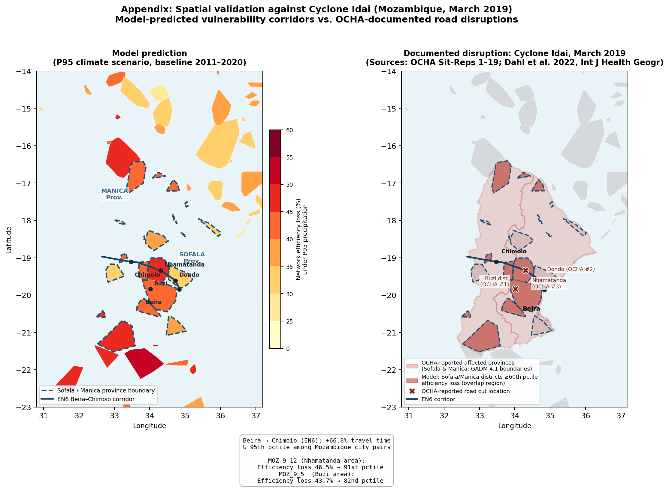
Supplementary Figure S1. Spatial validation: model-predicted road vulnerability vs. Cyclone Idai documented disruptions (Mozambique, 2019). Left: district-level network efficiency loss (%) under the P95 climate scenario; Sofala and Manica province boundaries are delineated (dashed). Right: OCHA-reported flood impact zone (Sofala Province, March 2019; light red) with model-predicted high-vulnerability districts (>=60th percentile efficiency loss) highlighted in dark red; x symbols indicate specific road-cut locations from OCHA Situation Reports 1-3. The EN6 Beira-Chimoio corridor is shown in both panels. Spatial correspondence between orange-to-red model-predicted districts and the documented disruption zone provides corridor-level evidence that the model identifies structurally susceptible road infrastructure.
9.2 Kenya floods case study (April-May 2024)
As a second qualitative spatial-consistency check, we compare model-predicted high-vulnerability corridors with documented road disruptions during the Kenya floods of April-May 2024. The comparison uses OCHA Flash Updates 1-6 and the ACAPS Briefing Note of 14 May 2024 as event documentation. As in the Idai case, this is not an event-prediction exercise; it tests whether the P95 climatological vulnerability layer highlights corridors and counties that later appeared in documented flood-related access disruptions.
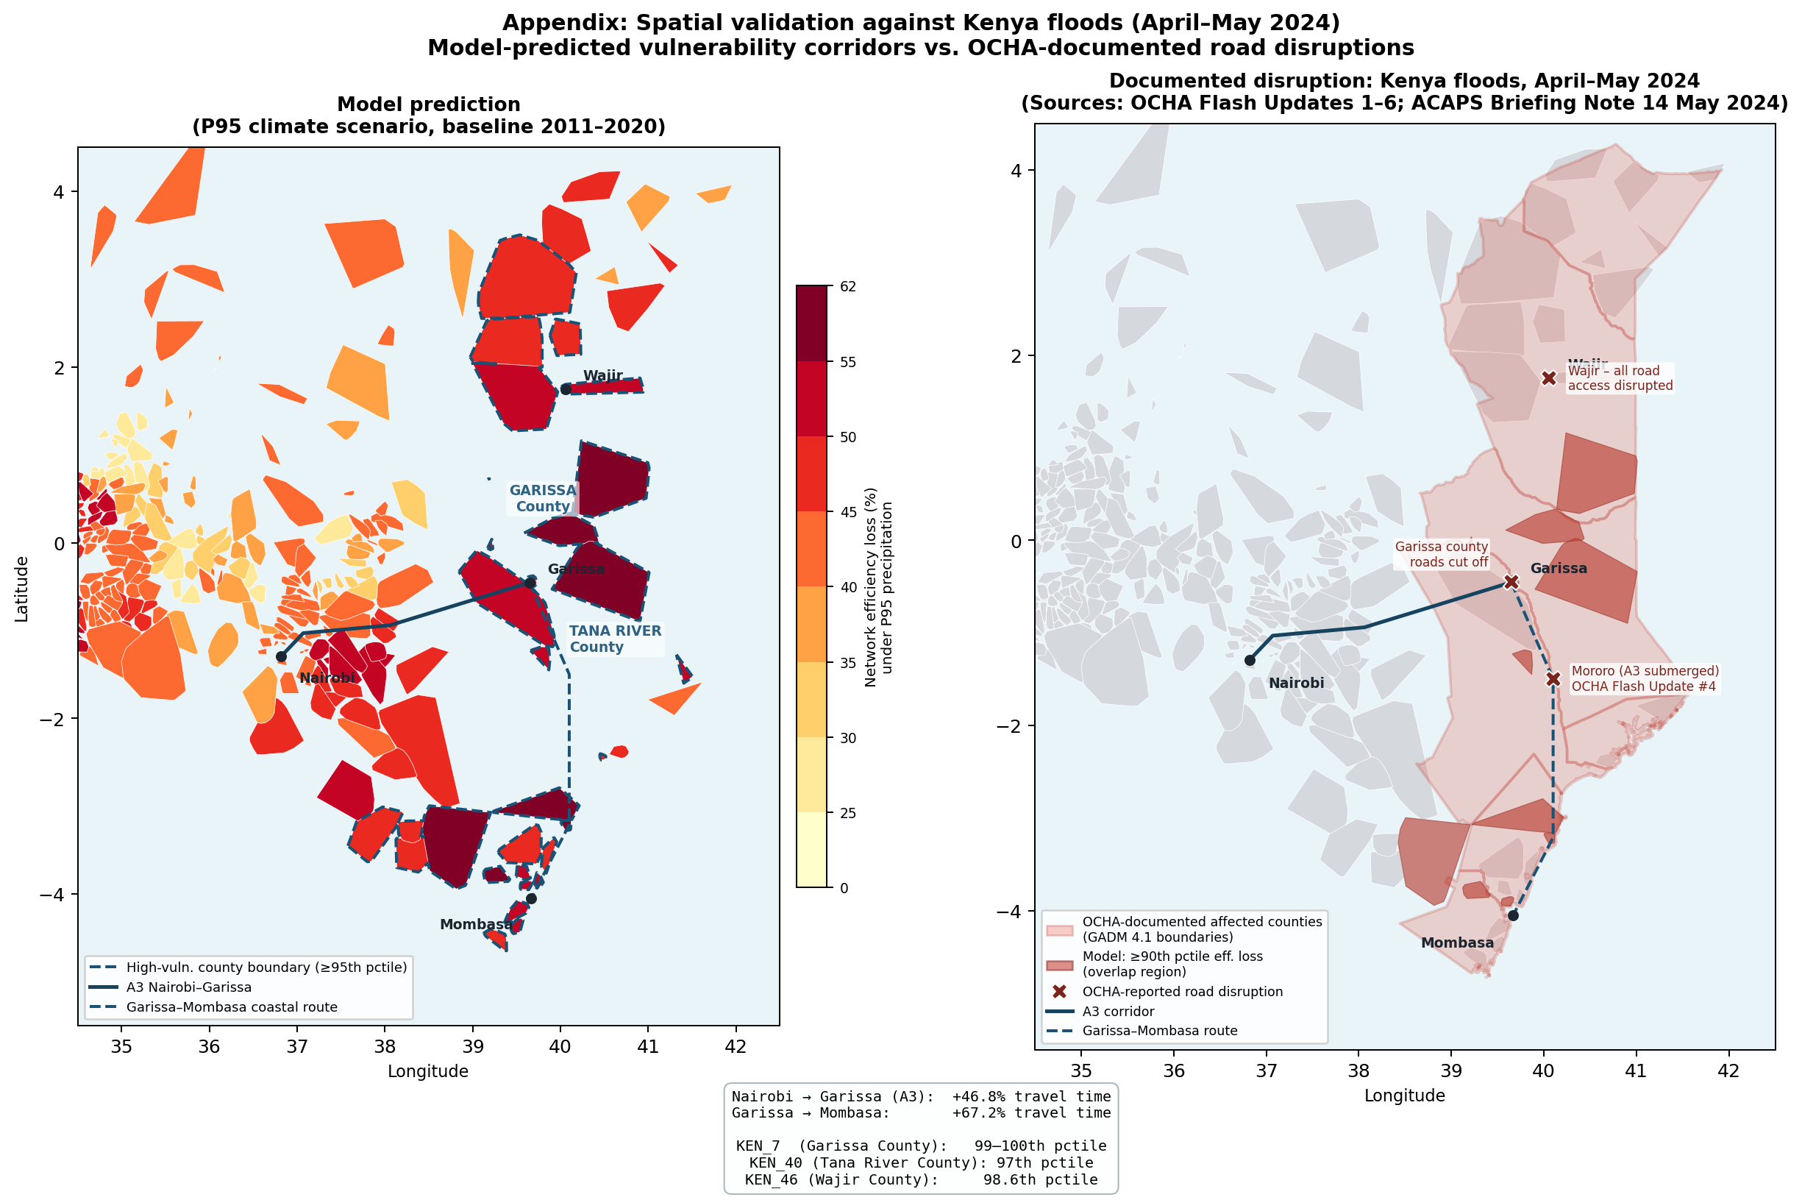
Supplementary Figure S2. Spatial validation: model-predicted road vulnerability vs. Kenya flood documented disruptions (April-May 2024). Left: district-level network efficiency loss (%) under the P95 climate scenario, with high-vulnerability county boundaries and the A3 Nairobi-Garissa and Garissa-Mombasa corridors shown. Right: OCHA-documented affected counties and reported road disruptions, including Wajir, Garissa county and Mororo, are overlaid with model-predicted high-vulnerability counties. The corridor-level correspondence supports the interpretation that the model identifies structurally susceptible road-infrastructure regions, while not claiming segment-level event prediction.
Supplementary Methods S10. Testing the temporal stability of priority bottlenecks
To examine whether present-day priority bottlenecks provide a robust basis for future adaptation planning, we repeated the segment-level bottleneck ranking under future climate projections for 2045, 2065 and 2085. All comparisons were restricted to the same baseline African road network and to segments classified as unpaved in the baseline inventory. This design holds network geometry fixed and isolates the effect of future climate-induced speed degradation on the relative importance of candidate paving segments.
For each time slice, we recalculated the bottleneck priority score using the same procedure as in the main analysis. Segment scores were then normalized within each period and converted into percentile ranks, allowing direct comparison between present-day and future rankings. We mapped the present-day priority distribution and the future change in segment rank to identify whether shifts in bottleneck importance were spatially widespread or concentrated in specific regions. Positive rank changes indicate segments that became more important under future climate conditions, whereas negative values indicate segments whose relative priority declined.
The resulting maps show that most high-priority bottlenecks remained spatially stable across the three future periods, with only localized turnover in areas such as eastern Ethiopia, eastern Angola and southern Morocco (Supplementary Fig. S3). This spatial pattern supports the use of present-day bottleneck rankings as a durable guide for targeted adaptation, while also identifying limited regions where future climate conditions may alter local prioritization.

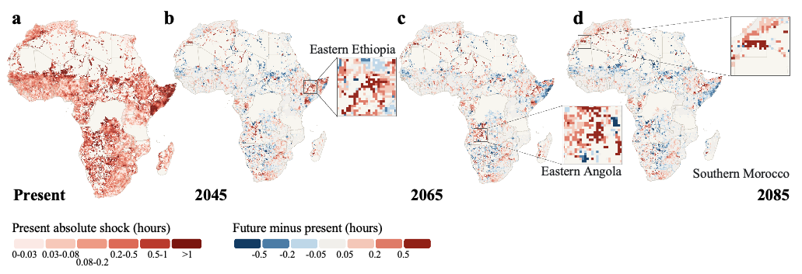
Supplementary Figure S3. Temporal stability of priority bottlenecks under future climate conditions. Present-day and future changes in priority bottleneck rankings across Africa’s unpaved road network. a, Present-day distribution of priority bottlenecks, with darker red indicating higher bottleneck priority. b–d, Changes in bottleneck priority rank under future climate conditions in 2045, 2065 and 2085, respectively, relative to the present-day ranking. Red tones indicate segments whose relative priority increases under future climate conditions, whereas blue tones indicate segments whose relative priority decreases. Insets highlight localized areas of relatively large turnover, including eastern Ethiopia, eastern Angola and southern Morocco. The broadly conserved spatial pattern indicates that priority bottlenecks are largely persistent through time, supporting their use as durable targets for adaptation planning.
References
ACAPS (2024). Kenya: Floods Briefing Note, 14 May 2024.
Petricola, S., Reinmuth, M., Lautenbach, S., Hatfield, C. & Zipf, A. (2022). Assessing road criticality and loss of healthcare accessibility during floods: the case of Cyclone Idai, Mozambique 2019. International Journal of Health Geographics 21, 14. https://doi.org/10.1186/s12942-022-00315-2

OCHA (2019). Mozambique: Cyclone Idai and Floods Situation Report Nos. 1-19. UN Office for the Coordination of Humanitarian Affairs.
OCHA (2024). Kenya floods Flash Updates 1-6. UN Office for the Coordination of Humanitarian Affairs.
World Bank (2019). After Cyclones Hit Mozambique, Massive Rebuild Restores Trade and Livelihoods.

